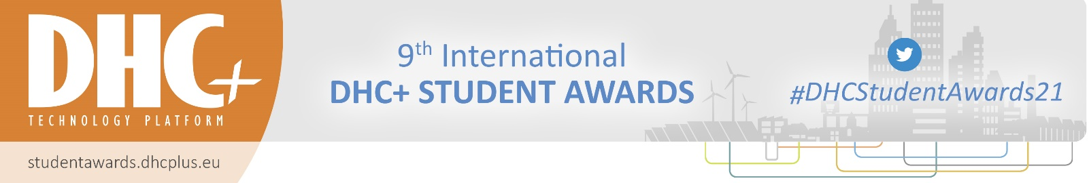
SPONSORSHIP COMMITMENT FORM
for the 9th International DHC+ Student Awards

to return to: DHC+ Technology Platform c/o Euroheat & Power
dhcplus@euroheat.org

Sponsorship opportunity (please tag):
☐ 9th International DHC+ Student Awards Sponsor €1.500 (excl. VAT)

CONTACT AND BILLING INFORMATION of the Sponsor
Company name Click or tap here to enter text.
Contact person Ms ☐ Mr ☐ First- Click or tap here to enter text. Surname Click or tap here to enter text.
Phone Click or tap here to enter text. Email Click or tap here to enter text.
Street Click or tap here to enter text. Zip code Click or tap here to enter text.
City Click or tap here to enter text. Country Click or tap here to enter text.
Billing address (if different from above) Click or tap here to enter text.
VAT number Click or tap here to enter text.

Please transfer the amount to:
ING Belgium
Cours Saint Michel B- 1040 Brussels
Account 363-0925234-88
IBAN BE56363092523488
SWIFT/BIC BBRU BE BB
Reference SA21spon_company name

The total amount must be paid within 30 days upon receipt of the invoice.

By signing, I confirm that I agree with the terms and conditions, as outlined on the next page of this document. In any disputes that may arise concerning the execution or interpretation of this contract, both parties agree that they will be subject to Belgian law and that the commercial courts of Brussels will be competent.

Name and function of the authorised individual: Date Click or tap to enter a date.
Click or tap here to enter text. Stamp & signature

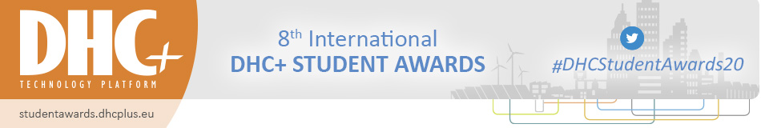
General Terms and Conditions

1. GENERAL REGULATIONS
1.1 DHC+ Technology Platform c/o Euroheat & Power aisbl (registered in Belgium, BE 0463.158.172-RPM) (DHC+) is the Organiser of the Student Awards (awards) and is empowered to accept or reject applications. Its decisions are final.
1.2 The signed form constitutes a legally binding contract for the Sponsor. The Organiser reserves the right to change or adapt the opportunities in case of unforeseen and/ or unavoidable circumstances, beyond its control.
1.3 Reselling of opportunities is strictly forbidden without the prior authorisation of the Organiser. In all cases the resell price must not exceed the price stated in this contract.
1.4 The latest, binding version of terms and conditions is available on the online page
https://www.euroheat.org/dhc-student-awards/
2. PAYMENT TERMS AND CONDITIONS
2.1 The amount due will be invoiced upon receipt of the signed contract (commitment form) and is to be paid within 30 days of the date of invoice.
2.2 After the 30 days an additional 5% on the amount still due will be surcharged as a penalty and an interest of 0.75 % per month will be added to the total amount still due.
2.3 Any bank charges are to be paid by the Sponsor.
2.4 In case of non-payment by the dates specified on the invoice, the Organiser reserves the right to reallocate the opportunity to another company. The Sponsor, however, remains bound by their contract and has to pay the totality of the amounts foreseen.
2.5 The opportunity will only be made available when the Sponsor has fulfilled all the obligations as stipulated in the contract and the General Terms and Conditions.
3. CANCELLATION
Withdrawal must be made by registered post to the DHC+ Secretariat. For cancellations made before 31 December 2020, 50% of the full amount as for the opportunity chosen will be payable. For cancellations as from 31 December 2020 the Sponsor has to pay the full amount as for the opportunity chosen. These cancellation policies will come into effect in all cases and whatever the reason for the withdrawal may be. Cancellation fees will be invoiced.
4. BANKRUPTCY OR LIQUIDATION
In case the Sponsor becomes bankrupt or enters into liquidation other than for the purpose of reconstruction or amalgamation, or has a receiver appointed, the Organiser shall be at liberty to terminate immediately the contract with the Sponsor, to cancel the opportunity and to forfeit all sums paid by the Sponsor.
5. SPONSOR RULES
5.1 Promotion with the official DHC+ logo is only possible through the channels offered by the Organiser or following permission by the DHC+ Secretariat.
5.2 All information related to logistical aspects of the opportunity will be sent to each Sponsor in due time.
6. INSURANCE
Subject to article 7.2.1, by way of their participation, Sponsors automatically relinquish all claims, in the event of an accident or damage against:
DHC+ Technology Platform c/o Euroheat & Power aisbl, event venues, the Sponsors at the event, the event participants, the directors, representatives, managers and officials appointed by these persons or bodies.
7. CIVIL LIABILITY
7.1 Of the Sponsor:
Subject to article 7.2.1 below, the company
supporting and its representative confirm that DHC+ Technology Platform c/o Euroheat & Power aisbl in no way takes responsibility for loss, injury or damage to items or persons, whatever the cause may be, before, during, or after the awards.
7.2 Of the Organiser:
7.2.1 DHC+ Technology Platform c/o Euroheat & Power aisbl is responsible under civil law in its capacity as Organiser of the awards and any other related events it organises. This liability shall however in no case extend to the damage caused to participants, visitors, sponsors or rented goods by third parties, unless in the event of death or injury exclusively caused by DHC+ Technology Platform’s negligence.
7.2.2 The awards venue(s) is/are responsible for its civil liability in its capacity as owner of the premises and of fixed or temporary installations used for the event, as well as for the management of the concerns and handling of the activities it administers directly.
7.2.3 Sponsors shall not be entitled to any compensation should political or economic circumstances or a case of “force majeure” prevent the awards from being held, or limit its size or modify its nature. Should it not be possible for the awards to take place, all fees shall remain the property of the Organiser up to a sum corresponding to the amounts for which he is already committed.
8. PRESENT REGULATIONS
The Organiser reserves the right to modify at any time the provisions of the present regulations.
9. DISPUTE
In any disputes that may arise concerning the execution or interpretation of the present General terms and conditions, both parties agree that they will be subject to Belgian law and that the commercial courts of Brussels will be competent.

